产品分析证书
Certificate of Analysis

产品信息(Product Information)
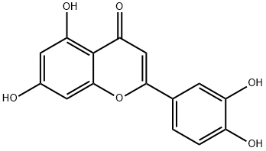
-----------------------------------------
产品编号（CAT No.）: N1288 中文名称：木犀草素
English Name：Luteolin
CAS No.: 491-70-3
分子式 (M. F.): C15H10O6 分子量 (M. W.): 286.24
批号 (Batch No.): 2203128801

检测项目及结果（Specifications&results）
--------------------------------------------
检验项目( Test Item） | 检验规格（ Specifications） | 检验结果（ Results）
颜色 Color | 类白色至淡黄色(Off-white to light yellow) | 淡黄色(light yellow)
外观 Appearance | 粉末或固体(Powder or Solid) | 粉末(Powder)
纯度 Purity | ≥98.0% by HPLC | Conforms
质谱 Mass | Comply with the structure | Conforms
核磁 NMR | Comply with the structure | Conforms
贮存条件（ Storage）:2~8℃, protected from light, keep package airproofed. <-15℃ when not in use for a long time.（密封保存，置于阴凉干燥处，长期不使用最好放置于-15℃以下环境中）
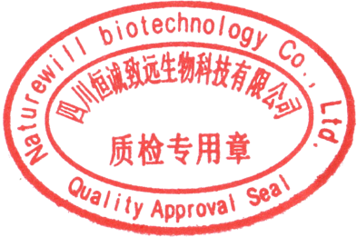
温馨提示（Reminder）:The sample solutions should be prepared immediately before use.(请现配现用)

QC: Ben Yang QA: Joy Li

产品售后 (After-sale service): In case of quality issue, please contact us within 15 days after receipt of the product. (若对于我们的产品质量有任何疑问，请于收到货后 15 天内联系我们）

HPLC Chromatogram
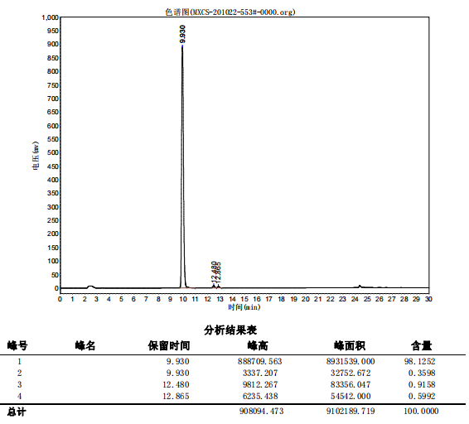

检测方法（Test Method）
------------------------------
色谱柱（Column）：Kromasil C18 250x4.6mm 5μ
流动相（Mobile phase):A 乙腈：B 0.03%磷酸溶液=A 30%-50%,10min 50%-65% 15min（A Acetonitrile: B 0.03%phosphoric acid solution = A 30%-50%,10min 50%-65% 15min）
检测波长（Detection mode）：350nm
柱温（Column temperature）：30℃

