产品分析证书
Certificate of Analysis

产品信息(Product Information)
-----------------------------------------
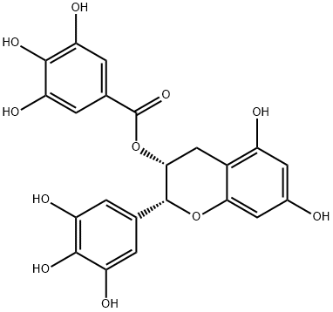
产品编号（CAT No.）: N1944中文名称：表没食子儿茶素没食子酸酯
English Name：EGCG
CAS No.: 989-51-5
分子式 (M. F.): C₂₂H₁₈O₁₁
分子量 (M. W.): 458.37
批号 (Batch No.): 2201194401

检测项目及结果（Specifications&results）
--------------------------------------------
检验项目( Test Item） | 检验规格（ Specifications） | 检验结果（ Results）
颜色 Color | 类白色至淡黄色(Off-white to light yellow) | 类白色(Off-white)
外观 Appearance | 粉末或固体(Powder or Solid) | 粉末(Powder)
纯度 Purity | ≥98.0% by HPLC | Conforms
质谱 Mass | Comply with the structure | Conforms
核磁 NMR | Comply with the structure | Conforms
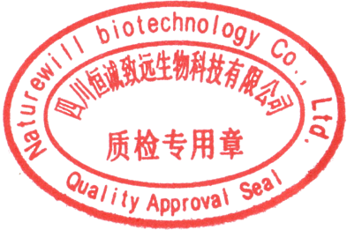
贮存条件（ Storage）:2~8℃, protected from light, keep package airproofed. <-15℃ when not in use for a long time.（密封保存，置于阴凉干燥处，长期不使用最好放置于-15℃以下环境中）
温馨提示（Reminder）:The sample solutions should be prepared immediately before use.(请现配现用)

QC: Ben Yang QA: Joy Li

产品售后 (After-sale service): In case of quality issue, please contact us within 15 days after receipt of the product. (若对于我们的产品质量有任何疑问，请于收到货后 15 天内联系我们）

HPLC Chromatogram
